**Persistent bill and corolla matching despite shifting temporal resources in tropical hummingbird-plant interactions**

MS submitted to Ecology Letters in the “Letters” category.

Ben G. Weinstein, corresponding author, email: [benjamin.weinstein@stonybrook.edu](mailto:benjamin.weinstein@stonybrook.edu)

Department of Ecology and Evolution, Stony Brook University, Stony Brook, New York 11794; USA

Catherine H. Graham, email: [Catherine.Graham@stonybrook.edu](mailto:Catherine.Graham@stonybrook.edu)

Department of Ecology and Evolution, Stony Brook University, Stony Brook, New York 11794; USA

Running Title: Hummingbird trait-matching and available resources

Abstract Length: 149

Main Text Length: 4710

Number of References: 61

Number of Figures: 6

Authorship: BW, CG developed the conceptual ideas for the MS; BW conducted the analyses; BW and CG wrote the MS.

Keywords: Co-evolution, Ecuador, Hummingbirds, Networks, Species Interactions

Data Accessibility:

Should the manuscript be accepted, the data supporting the results will be archived in an appropriate public repository such as Dryad or Figshare and the data DOI will be included at the end of the article.

# Abstract

By specializing on specific resources, species may evolve advantageous morphologies to increase the efficiency of nutrient acquisition. However, many specialists face annual variation in resource availability and composition. Whether morphological specialists can respond to changes in resources depends on the composition of the resource pulses, the costs of foraging on resources that do not match the consumer’s feeding morphology, and the strength of interspecific competition. Using time-lapse cameras, we collected data on the matching between hummingbird bill and plant corolla lengths across seasonal variation in flower availability and morphology. We differentiated interactions that were detected, non-detected, and could not occur based on overlap in elevation ranges using a hierarchical Bayesian approach. We found that despite seasonal changes in the morphology of available corollas, hummingbirds consistently preferred foraging on flowers which matched their bill lengths, leading to low niche overlap among morphologically different species. These results suggest that despite perceived costs of searching for rare and more specialized resources, hummingbirds maintain their resource niches throughout the year. This is consistent with strong tradeoffs in foraging efficiency and high interspecific competition, and highlights the contribution of tropical niche partitioning to local diversity.

# Introduction

Diet specialization, the use of a subset of available resources, is considered one of the major mechanisms permitting species co-occurrence through reduced niche overlap (Gause 1934; MacArthur 1958; Chesson 2000; Levine & HilleRisLambers 2009). Diet specialists often have morphological adaptations that allow them to extract resources more efficiently as compared to species with generalist feeding morphologies (Futuyma & Moreno 1988; Forister *et al.* 2012). In mutualistic interactions, reciprocal morphological adaptations, such as between plant corollas and pollinator mouthparts, may result in trait-matching, in which species that have similar traits tend to interact more often (Thomson 2003; Stang *et al.* 2009; Vázquez, Chacoff & Cagnolo 2009; Bartomeus *et al.* 2016). From the perspective of a pollinator, using a plant with a well-matched trait increases its ability to efficiently extract nutrients (Feinsinger & Colwell 1978; Maglianesi *et al.* 2014; Sazatornil *et al.* 2016). Trait-matching is an important mechanism in shaping ecological communities across many mutualist systems (Stang *et al.* 2009; Vizentin-Bugoni, Maruyama & Sazima 2014; Dehling *et al.* 2014; González-Castro *et al.* 2015; Olito & Fox 2015), and may play a role in reciprocal co-evolution among plants and pollinators (Thomson 2003; Castellanos, Wilson & Thomson 2004; Muchhala & Thomson 2009).

While the importance of trait-matching has been well documented, temporal variation in trait-matching is understudied. Species that rely on ephemeral resources, such as fruits and flowers, may have to cope with changes in the morphology of available resources (Jordano 1987; Yang *et al.* 2008; Correa & Winemiller 2014; Miller-Struttmann & Galen 2014). It may therefore be challenging for species with fixed morphological adaptations to switch to more abundant resources that are poorly matched to their feeding morphology (Schoener 1971; Carnicer, Abrams & Jordano 2008). By studying how seasonal changes in corolla morphology influence trait-matching, we can gain insight into the tradeoff between the reduced foraging efficiency of feeding on poorly-matched resources versus the cost of searching for well-matched resources (Robinson & Wilson 1998; Sargent & Ackerly 2008). Here we investigate the matching between hummingbird bill lengths and flower corolla lengths during annual cycles of flower abundance in a tropical cloud forest. When the difference between a hummingbird bill length and flower corolla length is small, the flower is considered a well-matched resource; if the difference is large, it is considered a poorly-matched resource.

The relationship between trait-matching and resource availability depends on the composition of resource pulses, the morphological characteristics of these resources, and the foraging strategies of competing consumer species (Robinson & Wilson 1998; Northfield *et al.* 2010; Tinker *et al.* 2012). Niche theory suggests that consumer species should preferentially forage on well-matched resources due to low handling times and a superior ability to extract nutrients (MacArthur 1958; Holt, Grover & Tilman 1994; Chesson 2000). If seasonal pulses are dominated by well-matched resources, a consumer species should abandon poorly-matched resources, leading to reduced niche overlap among morphologically different species (Fig. 1a). Alternatively, if seasonal pulses are dominated by poorly-matched resources, but the negative impact of reduced foraging efficiency is minimal, a consumer species might reduce its preference for rarer well-matched resources (Robinson & Wilson 1998). This pattern would lead to increased niche overlap among morphologically different consumer species (Fig. 1b) (Schoener 1971; Abrams 1991). Finally, if the costs of foraging on poorly-matched resources are large, then a consumer species may forage on well-matched resources regardless of relative resource availability (Wilson & Yoshimura 1994). In this scenario, there would be no change in niche overlap among morphologically different species through time (Fig. 1c).

To evaluate seasonal variation in trait-matching, we collected data on hummingbird-plant interactions from northwest Ecuador. Tropical hummingbirds and their food plants are quintessential examples of diffuse co-evolution, with hummingbirds foraging on flower corollas that tend to match their bill length (Feinsinger 1976; Maglianesi *et al.* 2014; Maruyama *et al.* 2014; Vizentin-Bugoni *et al.* 2014). In tropical montane forests, the timing of mass flowering is related to annual cycles of precipitation (Van schaik *et al.* 1993). In general, mid-elevation forests have spikes in flower abundance at the end of rainy season, with only a very small number of species in continuous flower (Hilty 1997). This pattern of flowering forces hummingbirds to choose among differing flowering plant species throughout the year (Stiles 1975).

One challenge in estimating trait-matching is collecting sufficient observations to differentiate between interactions that do not occur, and interactions that were not detected (Chacoff *et al.* 2012). By using multiple time-lapse cameras, followed by computer vision software to review footage, we were able to greatly increase our sampling effort (Weinstein 2015). To separate the probability of interaction occurrence from the probability of interaction detection, we used a hierarchical Bayesian approach that accounts for the detectability of hummingbird species. Similar to the N-mixture models developed in wildlife ecology (Royle 2004), we assumed that there is a true, but unobserved, number of interactions, and treated each day of camera filming as an attempt to capture this daily interaction rate among birds and flowers. This approach has three main benefits: it differentiates the probability of an interaction from the probability of observing an interaction, it captures the uncertainty in estimating interactions among plant and hummingbird species, and it fits a mechanistic relationship for species interactions based on trait-matching and resource availability.

# Methods

*Data Collection*

Data were collected along a single elevation gradient between the Maquipucuna Research Station and Santa Lucia Ecolodges, Ecuador (0.118 S,-78.612 W) between June 2013 and October 2015, and again from April 2016 to July 2016. At this site, there is a cooler rainy season (Dec – May) and a warmer dry season (June – October). The site contains primary and regenerating cloud-forest and spans an elevation gradient from 1300m to 2500m. We divided this elevation gradient into six 1 km transects that spanned approximately 200m in elevation.

We conduced bi-monthly flower transects to count hummingbird-visited flowers in bloom within 5m of pre-established trails. Hummingbirds forage on a wide range of flowers, therefore it is difficult to use flower morphology and color (i.e., tubular corolla shape, red and purple color) to determine which flowers will be visited by hummingbirds. We carefully evaluated all flowers based on observations during the floral transects, camera recording sessions (see below), incidental records, field guides, and local expert knowledge. For each flowering plant, we either directly counted flowers or extrapolated flower abundance by multiplying the number of flowers on at least 3 stalks by the number of total stalks on a plant. We then calculated the total number of hummingbird available flowers for each transect for each month by taking the average of the two monthly counts. We divided flower counts from the transects into low, medium and high resource availability periods based on whether the total number of flowers fell into the lower (0-300 flowers), middle (300-667 flowers) or upper third (above 667 flowers) of all flower transect counts. These periods generally correspond to before, during, and after the rainy season (Loiselle & Blake 1993; Hilty 1997). We defined the temporal window of our analysis to the timing and location of resources, rather than the calendar month. The distribution of flowering counts was weakly right skewed, with more monthly transect flower counts in the high resource period (n = 64) than in low resource period (n = 62).

We used observations along the transects to estimate hummingbird species elevation ranges. Upper and lower elevation ranges were based on the 95th quantile of observation records for each bird species (Figure S1). Hummingbird bill morphology was taken from published data sources (Graham et al. 2012). We measured corolla length, defined as the distance from the flower opening to the back of corolla, on at least three plants per species. Wherever possible, we estimated the effective corolla distance by cutting open flowers and measuring the corolla length extending back to the flower nectaries. For a minority of species, we were unable to measure floral characteristics, and used values from scaled photographs and local field guides from the UC Davis Herbarium survey of the Maquipucuna Valley (Webster & Rhodes 2001). We removed species from the final dataset if we did not have corolla morphology (n=13). Only one of the removed plant species (*Pitcairnia nigra)* was in the top twenty-five most visited plant species.

To determine which birds fed on which plants, we used time-lapse cameras (Plotwatcher Pros - Day 6) placed 1-3 meters from blooming flowers identified during floral transects. Up to twelve cameras were placed during each bi-monthly transect, depending on the availability of accessible flowers. We placed cameras on flowers across a wide variety of morphologies to ensure we captured the broadest floral use. Cameras turned on automatically at dawn and recorded an image every second for at least one day. After a maximum of five days, cameras were moved to a new set of blooming flowers. We used the computer vision program MotionMeerkat to identify images that contained movement, followed by manual review of these candidate frames to identify hummingbirds (Weinstein 2015). Only hummingbird species whose elevation ranges overlapped with the camera were considered available to interact with a given flower. We excluded one hummingbird from our analysis, Sparkling Violetear (*Colibri coruscans*), because it only briefly visited our field-site during the year.

*Hierarchical Bayesian N-mixture Model for Species Interactions*

We used an N-mixture model that assumes that there is a true, but partially observed, number of interactions between a given flower and hummingbird species. Due to sampling constraints, field observations will only detect a portion of the true number of interactions within a fixed period (Chacoff *et al.* 2012). Our approach explicitly models this uncertainty by treating each day of camera filming as an attempt to capture the true daily interaction rate among hummingbirds and flower. In this way, we differentiated the number of interactions per day from the probability of detecting an interaction, given that it occurs. The full model reads, for each observation () of a hummingbird species (i) feeding on plant species (j), during each month (k), on sampling day (d) there is a true number of interactions (). Our ability to observe this true state is governed by the detectability of each hummingbird species. The daily visitation rate is a function of the difference in traits between hummingbird bill length (i) and flower corolla length (j),with an interaction term for the resource availability period (low, medium, high) during month (k). The covariate () is the effect of trait-matching on visitation rates. Since trait-matching is the difference between bill and corolla lengths, a more negative value indicates greater trait-matching. The covariate is the effect of increasing resource availability when the difference between bill and corolla lengths is zero. The covariate is the interaction between resource availability period (eg. low, medium and high) and trait-matching. We use the resource availability period as our predictor of visitation rates, rather than the abundance of a given plant species (as in Krishna *et al.* 2008; Vázquez *et al.* 2009; Maruyama *et al.* 2014; Bartomeus *et al.* 2016), because we believe it is the seasonal change in resource availability which may influence trait-matching. Covariates were considered to have significant biological relevance if their posterior distributions did not overlap with zero. To create posteriors distributions, two MCMC chains were run for 300,000 draws. We then sampled 5,000 draws, saving every 10th draw, to reduce autocorrelation, to create 500 posterior samples. We parameterized process and observation variance using precision, rather than standard deviation (e.g. precision of 10 is equal to a standard deviation of 0.31).

Observation Model

Process Model

Priors

To determine whether niche overlap varied among resource periods, we generated 500 daily interaction networks for the high, medium, and low resource periods by simulating daily interaction rates from the model’s posterior distributions. For each of these predicted networks we calculated niche overlap among hummingbird species using horns distance (R package bipartite (Dormann *et al.* 2009)). The virtue of using the model posteriors to generate networks is that we can use the uncertainty in detecting species interactions to estimate the uncertainty in network statistics.

# Results

We conducted a total of 373 floral transects, recording 17,803 plants in bloom. We recorded 5093 hummingbird observations on these transects, which we used to estimate species elevation ranges (Fig. S1). Elevation ranges were largely constant throughout the year, with a distinct low and high elevation community. Tawny-bellied Hermit was the only species observed in all transects along the elevation gradient.

We placed cameras on 394 flowers in the field for a total of 498 days (~ 6,000 hours). Our cameras recorded 1654 interactions across 19 hummingbird bird species and 40 plant species for which we had complete morphological and taxonomic information. The taxonomic diversity of hummingbird-visited plants included 23 genera from 13 families dominated by Gesneriaceae, Rubiaceae, Ericaceae and Heliconiaceae. While many of the observed interactions included flowers with traditional hummingbird-visited traits (elongated corollas, red coloration, e.g. *Macleania bullata*), hummingbirds often visited cuplike flowers (*Meriania tomentosa*), blue flowers (*Palicourea lineata)*, white flowers (*Drymonia brochidodroma*), and flowers from unexpected taxonomic lineages (eg. S*tromanthe stromanthoides*). There were 10 plant species for which we placed cameras to determine if the flowers were hummingbird-visited, but found no visitation (Table S2).

Resource availability was highest at the beginning and middle of the dry season (Jun – September) and there was broad temporal overlap of resource pulses among years (Fig. 2). Flowering abundance peaked earlier at lower elevations (June, July) than at higher elevations (August, September). The timing of flowering was largely constant among years at all elevations. Resources pulses were dominated by sub-canopy trees *P. demissa* at low elevations, *Besleria solanoides* at mid-elevations, and *P. lineata* at high elevations. The blooms from these sub-canopy trees resulted in a greater proportion of flowers with short corollas in the high resource period (Fig. 3). The mean corolla length in the high resource period was shorter than the mean corolla length in the low resource period for all years and elevation transects. This pattern was strongest for the 1900m -2100m transect ( and weakest for the 2300m to 2500m elevation transect ( (Table S1).

The mean detectability of hummingbird interactions was 23.3% (min = 16%, max = 44%; Table 1). The variance in detectability was low for hummingbird species with many observations, but was broad for species observed on less than ten cameras. The trait-matching covariate () was significant for sixteen of the nineteen hummingbird species. The remaining three species (Green-fronted Lancebill, Andean Emerald, and Green-crowned Brilliant) had inconsistent or no preference for corollas that matched their bill lengths (Fig. 4). We found 156 observations of flower piercing, in which hummingbirds bypassed the corolla opening and inserted their bills directly into the corolla base (Table S3). For the most common piercer (Stripe-throated Hermit), the number of observed piercing events during the high resource period (n=90) was more than twice the number of events during the low resource period (n=33). This pattern was not consistent for the other species which used piercing less frequently (Fig. S2).

Only three of the nineteen species had significant estimates for the interaction between trait-matching and resource period ( (Table 1, Fig. 4). White-whiskered Hermits shifted towards using more poorly-matched flowers during periods of high resource availability. Collared Incas and Gorgeted Sunangels shifted towards using more well-matched flowers during periods of high resource availability. The remaining sixteen species showed no significant change in trait-matching between low, medium and high resource availability periods. Model evaluation showed reasonable fit for the majority of species, but under-predicted high daily counts among well-matched hummingbirds and resources (Fig. S3).

The predicted mean niche overlap among hummingbirds was low and broadly overlapping for low, medium and high resource periods (mean: low= 0.23, medium = 0.24, high = 0.25) (Fig. 5). The variance in niche overlap (low = 0.19, medium = 0.18, high = 0.18) was similar among resource periods. Overall, the predicted networks based on the detectability of interactions and the importance of trait-matching did not show a strong change in niche overlap during annual changes in flower abundance and morphology.

# Discussion

The co-occurrence of species often depends on niche differences among competitors (Gause 1934; MacArthur 1958; Chesson 2000; Levine & HilleRisLambers 2009). Species often have specialized morphology enabling them to increase the efficiency of nutrient extraction from resources that match their morphology (Futuyma & Moreno 1988). We found that despite large changes in the morphology and abundance of corollas throughout the year, the majority of hummingbirds maintained their preference for well-matched resources (Fig 1c). During resource pulses, hummingbirds could have favored hyper-abundant resources (Fig. 1b), if the cost of searching for well-matched resources was greater than the increased handling time associated with poorly-matched resources (Robinson & Wilson 1998; Muchhala & Thomson 2010). However, the lack of a strong shift by long-billed birds to more abundant short corolla flowers highlights the importance of hummingbird foraging efficiency whereby they more quickly extract nectar from well-matched resources (Feinsinger 1976; Rico-Guevara & Rubega 2011; Maglianesi *et al.* 2014). These results support trait-matching and niche partitioning among hummingbirds as potential mechanisms promoting co-occurrence in a diverse tropical community (Stiles 1978; Maglianesi *et al.* 2015; Sazatornil *et al.* 2016).

While the majority of hummingbirds used well-matched resources throughout the year, three species (Stripe-throated Hermit, Fawn-breasted Brilliant, Wedge-billed Hummingbird) more often used poorly-matched resources. This lack of trait-matching is likely because these species often pierce the base of flower corollas, thereby bypassing the morphological constraints of trait-matching (Fig. S4). Piercing was exclusively observed in short-billed birds accessing long-corolla flowers, suggesting that this may be a behavioral adaptation to allow for increased foraging breadth (Feinsinger & Colwell 1978).

The theory of trait-matching among interacting species assumes that species incur a cost by feeding on poorly-matched resources (Jordano 1987; Bascompte & Jordano 2007; Bartomeus *et al.* 2016). However, tradeoffs in foraging are often assumed, rather than tested, and there are cases where evidence suggests a lack of tradeoffs (Futuyma & Moreno 1988; Wilson & Yoshimura 1994; Cogni, Trigo & Futuyma 2012; Remold 2012). MacArthur’s adage ‘The jack of all trades is the master of none’ (MacArthur 1972), would lead us to believe that trait-matching would be the rule among co-occurring species trying to maximize foraging efficiency. However, perceived morphological specialists may occasionally act as generalists, often called ‘Liem’s paradox’ (Liem 1973), underlining the importance of monitoring species interactions through time (Olesen *et al.* 2008; Petanidou *et al.* 2008; Poisot, Stouffer & Gravel 2015). Our observed lack of shift by long-billed birds to more abundant short corolla flowers, combined with the tremendous metabolic demand of hovering flight (Altshuler & Dudley 2002), the agonistic interactions among individuals (Powers 1987), and the data on improved nectar extraction rates for well-matched interactions (Rico-Guevara & Rubega 2011; Maglianesi *et al.* 2014), suggest it is reasonable to infer a foraging tradeoff for hummingbird with specialist morphologies.

Increased interaction rates among species with well-matched traits has been highlighted in variety of systems, including hummingbird-plant interactions (Maglianesi *et al.* 2014; Maruyama *et al.* 2014; Vizentin-Bugoni *et al.* 2014; Abrahamczyk, Souto-Vilarós & Renner 2014), frugivore-plant interactions (Donatti *et al.* 2011; Dehling *et al.* 2014; González-Castro *et al.* 2015), insect-plant interactions (Stang *et al.* 2009; Kaiser-Bunbury *et al.* 2014; Olito & Fox 2015; Sazatornil *et al.* 2016) and marine food-webs (Gravel *et al.* 2013). However, our study is one of the first to evaluate the interaction effect between trait-matching and seasonal changes in resource morphology. While there are many examples of seasonal diet switching (Foster 1977; Carnicer *et al.* 2008; Correa *et al.* 2014), previous studies have not explicitly measured seasonal changes in trait-matching, limiting our ability to predict under what conditions trait-matching is favored in natural systems. Experimental evidence indicates that animals balance the search time needed to find well-matched resources, versus the ease of use of poorly-matched resources (Connell 1983; Pyke 1984). For example, Levey (1984) found that tropical frugivores consumed less preferred fruits when the distance among preferred fruits was experimentally increased. In our system, the pulse of resources are distributed in distinct patches (i.e., sub-canopy trees), such that they can be dominated by relatively few individuals from aggressive species (Temeles *et al.* 2004). If resources were uniformly distributed across a landscape, it would be impossible to defend all patches, thereby reducing competition and increasing foraging breadth (Macarthur & Pianka 1966; Mac Nally & Timewell 2005). While the relationship between morphology and spatial patterning of tropical resources is not well known (Loiselle & Blake 1993), newly developed tracking technologies may clarify the energetic costs of hummingbird foraging movements in searching for well-matched resources (eg. Hadley & Betts 2009).

The separation of species niches through trait-matching may help explain the modularity reported in many mutualistic networks (Dalsgaard *et al.* 2013; Martín González *et al.* 2015). In general, strong trait-matching will lead to greater specialization and modularity within assemblages (Carstensen, Sabatino & Morellato 2016). This modularity may lead to greater isolation among hummingbird-visited plants with different floral morphology; thereby minimizing hybridization, pollen loss and competition for pollinator services (Castellanos *et al.* 2004; Muchhala & Thomson 2010). In this way, trait-matching can shape the diversity of assemblages, and the potential co-evolution of plant-pollinator interactions (Muchhala & Thomson 2009).

While the potential importance of temporal change on inferring network properties has been extensively discussed (Vázquez & Aizen 2004; Poisot *et al.* 2015), there have been few datasets with sufficient detail to capture changes in species interactions through time (Petanidou *et al.* 2008; Olesen, Stefanescu & Traveset 2011). We used time-lapse cameras, computer vision and a hierarchical Bayesian approach to increase sampling and differentiate the uncertainty in detecting an interaction from the underlying probability of interaction among network partners (Bartomeus 2013). Within our dataset, we saw species specific trait-matching relationships and changes through time. Given the idiosyncratic results for individual species, methodological approaches that use aggregated interaction matrices may overlook species-level complexity in network partners (Olito & Fox 2015; Carstensen *et al.* 2016).

Further study of trait-matching, requires broader-scale studies across evolutionary lineages, species richness and community composition (Dalsgaard *et al.* 2013; Poisot *et al.* 2015). There may be reduced trait-matching in young assemblages, due to insufficient time for such adaptations to evolve, or in species poor assemblages, due to reduced competitive pressure on the efficiency of resource extraction (MacArthur, Diamond & Karr 1972; Costa *et al.* 2008). For example, Dalsgaard *et al.* (2016) suggested that the depauperate hummingbird community on Cuba has led to the unusual diversity of nectar-feeding avifauna. This pattern may relate to the density of trait space within assemblages, such that in areas of low functional density, there is weaker pressure on trait-matching (Bartomeus *et al.* 2016). However, Sazatornil et al. (2016) found evidence for the reverse, in assemblages with a greater proportion of morphological specialists, there was reduced evidence for trait-matching. Whether the importance of trait-matching depends on trait spacing among competitors remains an interesting and open question. By combining observations from multiple sites, mechanistic models of trait-matching, and accounting for the detectability of interactions, we can gain a more detailed insight into why species interactions vary across time and space.

# References

Abrams, P.A. (1991). Life-History and the relationship between food availability and foraging effort. *Ecology*, 72, 1242–1252.

Altshuler, D. & Dudley, R. (2002). The ecological and evolutionary interface of hummingbird flight physiology. *J. Exp. Biol.*, 205, 2325–2336.

Bartomeus, I. (2013). Understanding Linkage Rules in Plant-Pollinator Networks by Using Hierarchical Models That Incorporate Pollinator Detectability and Plant Traits. *PLoS ONE*, 8, 1–8.

Bartomeus, I., Gravel, D., Tylianakis, J.M., Aizen, M., Dickie, I. & Bernard-Verdier, M. (2016). A common framework for identifying rules across different types of interactions. *Funct. Ecol*., 10, 1–40.

Carnicer, J., Abrams, P.A. & Jordano, P. (2008). Switching behavior, coexistence and diversification: Comparing empirical community-wide evidence with theoretical predictions. *Ecol. Lett.,* 11, 802–808.

Castellanos, M.C., Wilson, P. & Thomson, J.D. (2004). “Anti-bee” and “pro-bird” changes during the evolution of hummingbird pollination in Penstemon flowers. *J. Evol. Biol.*, 17, 876–885.

Carstensen, D.W., Sabatino, M. & Morellato, L.P.C. (2016). Modularity, pollination systems, and interaction turnover in plant-pollinator networks across space. *Ecology*, 97, 1298–1306.

Chacoff, N.P., Vázquez, D.P., Lomáscolo, S.B., Stevani, E.L., Dorado, J. & Padrón, B. (2012). Evaluating sampling completeness in a desert plant-pollinator network. *J. Anim. Ecol.*, 81, 190–200.

Chesson, P. (2000). Mechanisms of Maintenance of Species Diversity. *Annu. Rev. Ecol. Syst.*, 31, 343–366.

Connell, J.H. (1983). On the Prevalence and Relative Importance of Interspecific Competition: Evidence from Field Experiments. *Am. Nat.*, 122, 661–696.

Correa, S. & Winemiller, K. (2014). Niche partitioning among frugivorous fishes in response to fluctuating resources in the Amazonian floodplain forest. *Ecology*, 95, 210–224.

Costa, G.C., Mesquita, D.O., Colli, G.R. & Vitt, L.J. (2008). Niche Expansion and the Niche Variation Hypothesis: Does the Degree of Individual Variation Increase in Depauperate Assemblages? *Am. Nat.*, 172, 868–877.

Cogni, R., Trigo, J.R. & Futuyma, D.J. (2012). A free lunch? No cost for acquiring defensive plant pyrrolizidine alkaloids in a specialist arctiid moth (Utetheisa ornatrix). *Mol. Ecol.*, 21, 6152–6162.

Dalsgaard, B., Baquero, A.C., Rahbek, C., Olesen, J.M. & Wiley, J.W. (2016). Speciose opportunistic nectar-feeding avifauna in Cuba and its association to hummingbird island biogeography. *J. Ornithol.*, 157, 627–634.

Dormann, C.F., Frund, J., Bluthgen, N. & Gruber, B. (2009). Indices, Graphs and Null Models: Analyzing Bipartite Ecological Networks. *Open Ecol. J.*, 2, 7–24.

Feinsinger, P. (1976). Organization of a tropical guild of nectarivorous birds. *Ecol. Monogr.*, 46, 257–291.

Forister, M.L., Dyer, L. a, Singer, M.S., Stireman, J.O. & Lill, J.T. (2012). Revisiting the evolution of ecological specialization, with emphasis on insect-plant interactions. *Ecology*, 93, 981–991.

Foster, M.S. (1977). Ecological and Nutritional Effects of Food Scarcity on a Tropical Frugivorous Bird and its Fruit Source. *Ecology*, 58, 73–85.

Futuyma, D.J. & Moreno, G. (1988). The evolution of ecological specialization. *Annu Rev Ecol Syst.*, 19, 207–233.

Futuyma, D. J. (2001) Ecological specialization and generalization. *Evolutionary ecology: concepts and case studies*. Oxford. Oxford University Press.

Gause, G.F. (1934). Experimental Analysis of Vito Volterra’s Mathematical Theory of the Struggle for Existence. *Science*, 79, 16–17.

Grant, P.R. & Grant, B.R. (2002). Unpredictable evolution in a 30-year study of Darwin’s finches. *Science*, 296, 707–11.

Graham, C. H. et al. (2012). Untangling the influence of ecological and evolutionary factors on trait variation across hummingbird assemblages. *Ecology*, 93, 99–111.

Hadley, A.S. & Betts, M.G. (2009). Tropical deforestation alters hummingbird movement patterns. *Biol. Lett.*, 5, 207–210.

Hilty, S. (1997). Seasonal Distribution of Birds at a Cloud-Forest Locality, the Anchicayá Valley, in Western Colombia. *Ornithol. Monogr.*, 321–343.

Holt, R.D., Grover, J. & Tilman, D. (1994). Simple Rules for Interspecific Dominance in Systems with Exploitative and Apparent Competition. *Am. Nat.,* 144, 741-771.

Jordano, P. (1987). Patterns of Mutualistic Interactions in Pollination and Seed Dispersal: Connectance, Dependence Asymmetries, and Coevolution. *Am. Nat.*, 129, 657-677.

Krishna, A., Guimaraes, J.P.R., Jordano, P. & Bascompte, J. (2008). A neutral-niche theory of nestedness in mutualistic networks. *Oikos*, 117, 1609–1618.

Levey, D.J., Moermand, T. & Denslow, J.S. (1984). Fruit choice in neotropical birds; the effects of distance between fruits on preference patterns. *Ecology*, 65, 844–850.

Levine, J.M. & HilleRisLambers, J. (2009). The importance of niches for the maintenance of species diversity. *Nature*, 461, 254–257.

Liem, K.F. (1973). Evolutionary Strategies and Morphological Innovations: Cichlid Pharyngeal Jaws. *Syst. Zool.*, 22, 425-441.

Loiselle, B.A. & Blake, J.G. (1993). Spatial distribution of understory fruit-eating birds and fruiting plants in a neotropical lowland wet forest. *Vegetatio*, 107-108, 177–189.

Lynch, H.J., Thorson, J.T. & Shelton, A.O. (2014). Dealing with under- and over-dispersed count data in life history, spatial, and community ecology. *Ecology*, 95, 3173–3180.

MacArthur, R. (1958). Population ecology of some warblers of northeastern coniferous forests. *Ecology*, 39, 599–619.

Macarthur, R.H. & Pianka, E.R. (1966). On optimal use of a patchy environment. *Am. Nat.*, 100, 603–609.

MacArthur, R. & Levins, R. (1967). The limiting similarity, convergence, and divergence of coexisting species. *Am. Nat.*, 101, 377–385.

MacArthur, R.H., Diamond, J.M. & Karr, J.R. (1972). Density Compensation in Island Faunas. *Ecology*, 53, 330–342.

MacArthur R. H. (1972). *Geographical ecology: patterns in the distribution of species*. New York. Harper & Row.

Mac Nally, R. & Timewell, C. (2005). Resource availability controls bird-assemblage composition through interspecific aggression. *Auk*, 122, 1097–1111.

Maglianesi, M.A., Bluthgen, N., Bohning-Gaese, K. & Schleuning, M. (2014). Morphological traits determine specialization and resource use in plant-hummingbird networks in the neotropics. *Ecology*, 95, 3325–3334.

Maruyama, P.K., Vizentin-Bugoni, J., Oliveira, G.M., Oliveira, P.E. & Dalsgaard, B. (2014). Morphological and Spatio-Temporal Mismatches Shape a Neotropical Savanna Plant-Hummingbird Network. *Biotropica*, 46, 740–747.

Miller-Struttmann, N.E. & Galen, C. (2014). High-altitude multi-taskers: bumble bee food plant use broadens along an altitudinal productivity gradient. *Oecologia*, 176, 1033–1045.

Muchhala, N. & Thomson, J.D. (2009). Going to great lengths: selection for long corolla tubes in an extremely specialized bat-flower mutualism. *Proc. R. Soc. B Biol. Sci.*, 276, 2147–52.

Muchhala, N. & Thomson, J.D. (2010). Fur versus feathers: Pollen delivery by bats and hummingbirds and consequences for pollen production. *Am. Nat.,* 175, 717–726.

Northfield, T.D., Snyder, G.B., Ives, A.R. & Snyder, W.E. (2010). Niche saturation reveals resource partitioning among consumers. *Ecol. Lett.*, 13, 338–48.

Olito, C. & Fox, J.W. (2015). Species traits and abundances predict metrics of plant-pollinator network structure, but not pairwise interactions. *Oikos*, 124, 428–436.

Olesen, J.M., Stefanescu, C. & Traveset, A. (2011). Strong, long-term temporal dynamics of an ecological network. *PLoS ONE*, 6, e26455.

Olesen, J.M., Bascompte, J., Elberling, H. & Jordano, P. (2008). Temporal dynamics in a pollination network. *Ecology*, 89, 1573–82.

Petanidou, T., Kallimanis, A.S., Tzanopoulos, J., Sgardelis, S.P. & Pantis, J.D. (2008). Long-term observation of a pollination network: fluctuation in species and interactions, relative invariance of network structure and implications for estimates of specialization. *Ecol. Lett.*, 11, 564–575.

Powers, D.R. & Conley, T.M. (1994). Field metabolic rate and food consumption of two sympatric hummingbird species in southeastern Arizona. *Condor*, 96, 141–150.

Remold, S. (2012). Understanding specialism when the Jack of all trades can be the master of all. *Proc. Biol. Sci.*, 279, 4861–9.

Rico-Guevara, A. & Rubega, M.A. (2011). The hummingbird tongue is a fluid trap, not a capillary tube. *Proc. Natl. Acad. Sci.*, 108, 9356–60.

Robinson, B.W. & Wilson, D.S. (1998). Optimal foraging, specialization, and a solution to Liem’s paradox. *Am. Nat.*, 151, 223–35.

Royle, J.A. (2004). N-Mixture Models for Estimating Population Size from Spatially Replicated Counts. *Biometrics*, 60, 108–115.

Sargent, R.D. & Ackerly, D.D. (2008). Plant-pollinator interactions and the assembly of plant communities. *Trends Ecol. Evol.*, 23, 123–30.

Sazatornil, F.D., Moré, M., Benitez-Vieyra, S., Cocucci, A.A., Kitching, I.J., Schlumpberger, B.O., *et al.* (2016). Beyond neutral and forbidden links: morphological matches and the assembly of mutualistic hawkmoth-plant networks. *J. Anim. Ecol.*, 85, 1586–1594.

Stang, M., Klinkhamer, P.G.L., Waser, N.M., Stang, I. & Van Der Meijden, E. (2009). Size-specific interaction patterns and size matching in a plant-pollinator interaction web. *Ann. Bot.*, 103, 1459–1469.

Schoener, T.W. (1971). Theory of Feeding Strategies. *Annu. Rev. Ecol. Syst.*, 2, 369–404.

Stiles, F. (1975). Ecology, flowering phenology, and hummingbird pollination of some Costa Rican Heliconia species. *Ecology*, 56, 285–301.

Stiles, F.G. (1978). Ecological and evolutionary implications of bird pollination*. Integr. Comp. Biol.*, 18, 715–727.

Temeles, E.J., Muir, A.B., Slutsky, E.B. & Vitousek, M.N. (2004). Effect of Food Reductions on Territorial Behavior of Purple-Throated Caribs. *Condor*, 106, 691–695.

Thomson, J. (2003). When is it mutualism? *Am. Nat.,* 162, S1–S9.

Tinker, M., Guimarães, P.R., Novak, M., Marquitti, F.M.D., Bodkin, J.L., Staedler, M., et al. (2012). Structure and mechanism of diet specialization: testing models of individual variation in resource use with sea otters. *Ecol. Lett.*, 15, 475–483.

Van schaik, C.P., Terborgh, J.W. & Wright, S.J. (1993). The Phenology of Tropical Forests - Adaptive Significance and Consequences for Primary Consumers. *Annu. Rev. Ecol. Syst.*, 24, 353–377.

Vázquez, D.P. & Aizen, M.A. (2004). Asymmetric Specialization : a Pervasive Feature of Plant-Pollinator Interactions. *Ecology*, 85, 1251–1257

Vázquez, D.P., Chacoff, N.P. & Cagnolo, L. (2009). Evaluating multiple determinants of the structure of plant-animal mutualistic networks. *Ecology*, 90, 2039–2046.

Vizentin-Bugoni, J., Maruyama, P.K. & Sazima, M. (2014). Processes entangling interactions in communities: forbidden links are more important than abundance in a hummingbird-plant network. *Proc. R. Soc. B Biol. Sci*., 281, 20132397–20132397.

Webster, G. and Rhodes, R. 2001. Plant Diversity of an Andean Cloud Forest: Inventory of the Vascular Flora of Maquipucuna, Ecuador. University of California Press.

Weinstein, B.G. (2015). MotionMeerkat: integrating motion video detection and ecological monitoring. *Methods Ecol. Evol.*, 6, 357–362.

Wilson, D.S. & Yoshimura, J. (1994). On the Coexistance of Specialists and Generalists. *Am. Nat.*, 144, 692–707.

Yang, L.H., Bastow, J.L., Spence, K.O. & Wright, A.N. (2008). What Can We Learn From Resource Pulses? *Ecology*, 89, 621–634.

Tables

Table 1. Mean detection probability () and interaction between trait-matching and resource period covariates ( for each hummingbird species. Negative covariates indicate trait-matching is increasing during periods of high resource availability. Significant covariate estimates are indiciated in bold. Species are sorted by detection probabilities.

|  |  |  |
| --- | --- | --- |
| Species |  |  |
| Wedge-billed Hummingbird (*Schistes geoffroyi*) | 0.16 (0.07, 0.28) | -0.01 (-0.03, 0.02) |
| Brown Inca (*Coeligena wilsoni*) | 0.17 (0.11, 0.25) | 0.03 (0.00, 0.49) |
| Collared Inca (*Coeligena torquata*) | 0.19 (.10, 0.31) | **-0.04 (-0.07, -0.01)** |
| Fawn-breasted Brilliant (*Heliodoxa rubinoides*) | 0.19 (0.09, 0.42) | 0.01 (-0.02, 0.04) |
| Speckled Hummingbird (*Adelomyia melanogenys*) | 0.19 (0.11, 0.28) | 0.02 (-0.01, 0.06) |
| Buff-tailed Coronet *(Boissonneaua flavescens)* | 0.19 (0.11, 0.31) | -0.03 (-0.08, 0.03) |
| Rufous-tailed Hummingbird (*Amazilia tzacatl*) | 0.21 (0.08, 0.37) | -0.01 (-0.08, 0.06) |
| Green-crowned Brilliant (*Heliodoxa jacula)* | 0.22 (0.09, 0.42) | 0.05 (0.00, 0.11) |
| Crowned Woodnymph (*Thalurania colombica*) | 0.22 (0.12, 0.34) | -0.01 (-0.04, 0.02) |
| Violet-tailed Sylph (*Aglaiocercus coelestis*) | 0.22 (0.12, 0.35) | -0.01 (-0.02, 0.00) |
| Booted Racket-tail (*Ocreatus underwoodii*) | 0.22 (0.14, 0.32) | -0.02 (-0.06, 0.03) |
| Hoary Puffleg (*Haplophaedia lugens*) | 0.23 (0.11, 0.39) | -0.02 (-0.09, 0.03) |
| Stripe-throated Hermit (*Phaethornis striigularis*) | 0.23 (0.13, 0.35) | 0.03 (-0.01, 0.06) |
| Purple-bibbed Whitetip (*Urosticte benjamini)* | 0.24 (0.11, 0.40) | 0.01 (-0.05, 0.06) |
| White-whiskered Hermit (*Phaethornis yaruqui*) | 0.25 (0.16, 0.37) | **0.03 (0.03, 0.05)** |
| Andean Emerald *(Amazilia franciae)* | 0.27 (0.13, 0.40) | -0.01 (-0.05, 0.03) |
| Green-fronted Lancebill (*Doryfera ludovicae*) | 0.27 (0.14, 0.42) | -0.02 (-0.06, 0.01) |
| Tawny-bellied Hermit (*Phaethornis syrmatophorus*) | 0.32 (0.20, 0.45) | 0.00 (-0.02, 0.01) |
| Gorgeted Sunangel (*Heliangelus strophianus)* | 0.44 (0.27, 0.65) | **-0.08 (-0.12, -0.04)** |

Figures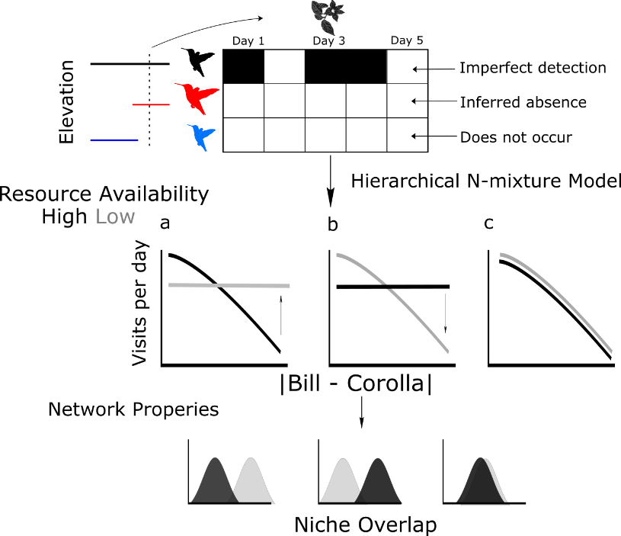

Figure 1. Conceptual figure for the relationship between trait-matching and resource availability. As resource availability increases, species could shift towards well-matched resources (a), poorly-matched resources (b), or stay static (c). The observation model differentiates between interactions that are not detected, interactions that do not occur, and interactions which cannot occur based on a lack of spatial overlap in elevation ranges. For clarity, only low (gray lines) and high (black lines) resource periods are shown. The medium resource period would fall between the predicted state for the low and high periods.

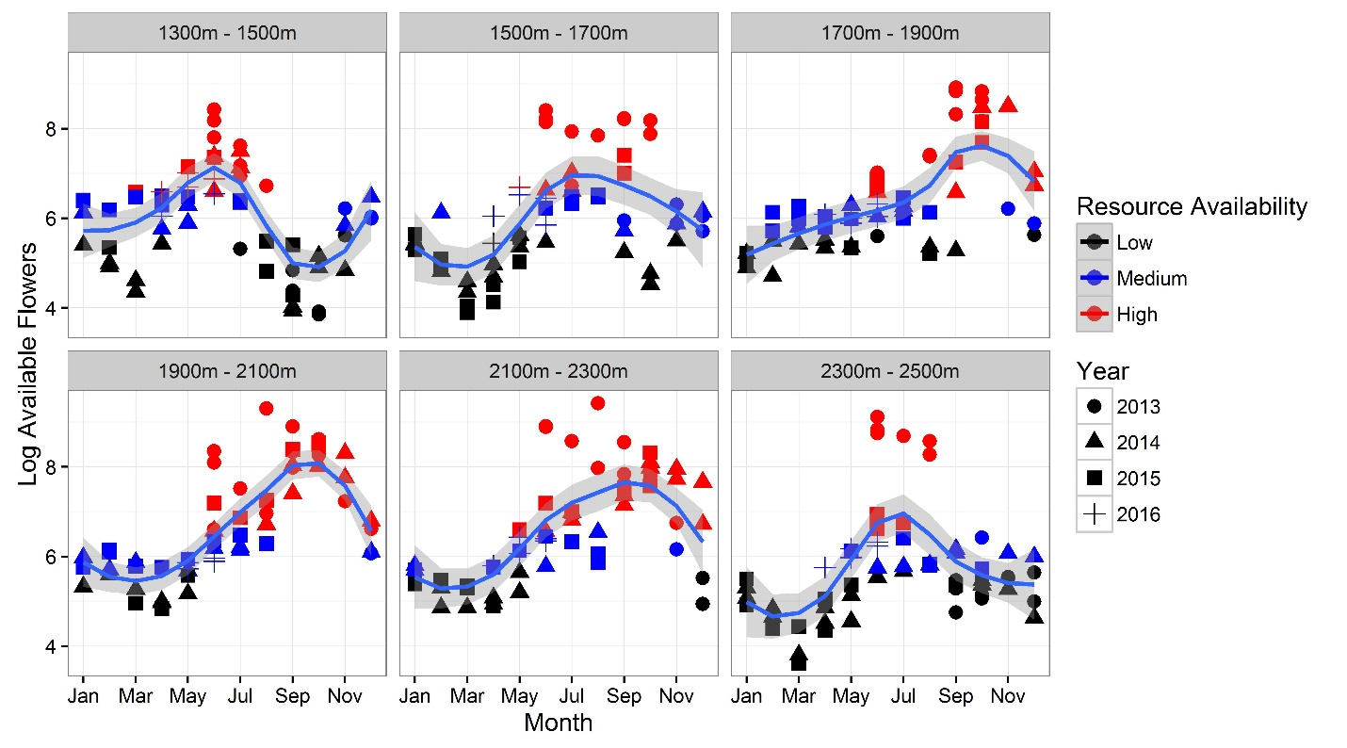

Figure 2. Log-transformed available floral resources for hummingbirds along each of the six elevation transects from northwest Ecuador. Transect elevation ranges are shown in the gray headings. Resource availability periods were defined by the upper, middle, and lower third of monthly flower counts. The blue line is the loess spline trend for each elevation transect throughout the year.

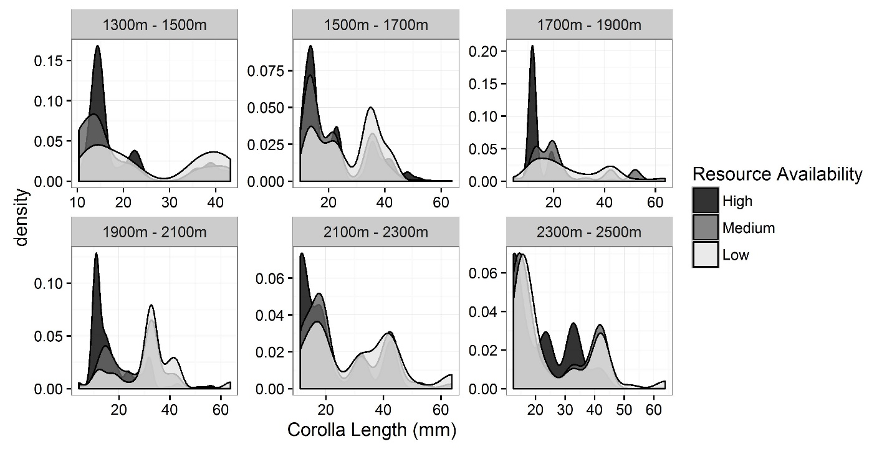Figure 3. The distribution of hummingbird-visited corolla lengths during high, medium and low resource periods along the six elevation transects in northwest Ecuador. These periods refer to the lower, middle and upper third of flower counts along the transects over the study period. During elevated resource periods there are greater proportion of shorter corollas, largely due to the mass flowering of sub-canopy trees in the genera *Besleria* and *Palicourea.* The more consistent flowering of *P. lineata* at the highest elevations leads to a less pronounced shift along the 2300-2500m transect.

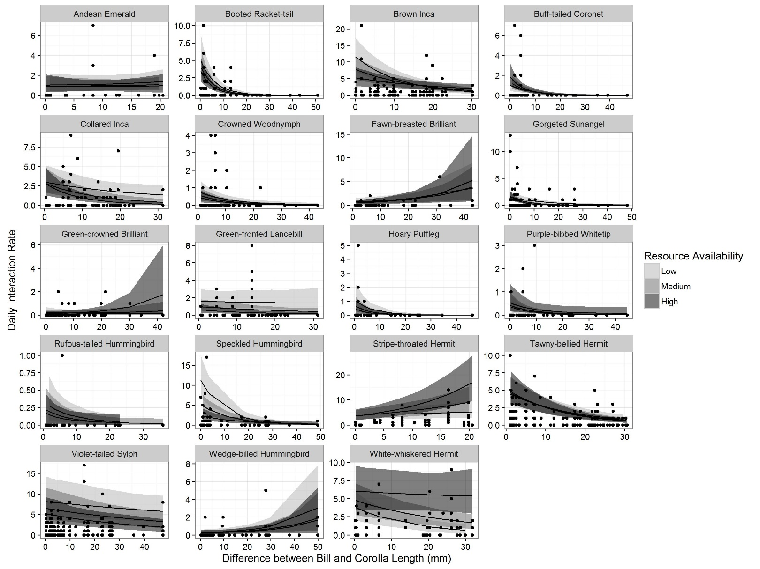

Figure 4. Trait-matching relationship among hummingbirds and plants during periods of low, medium, and high resource availability periods from a cloud-forest in northwest Ecuador. Trait-matching is measured as the difference between bill and corolla lengths, therefore a negative slope is indicative of positive trait-matching. Ninety-five percent credible intervals are shown in the shaded regions.

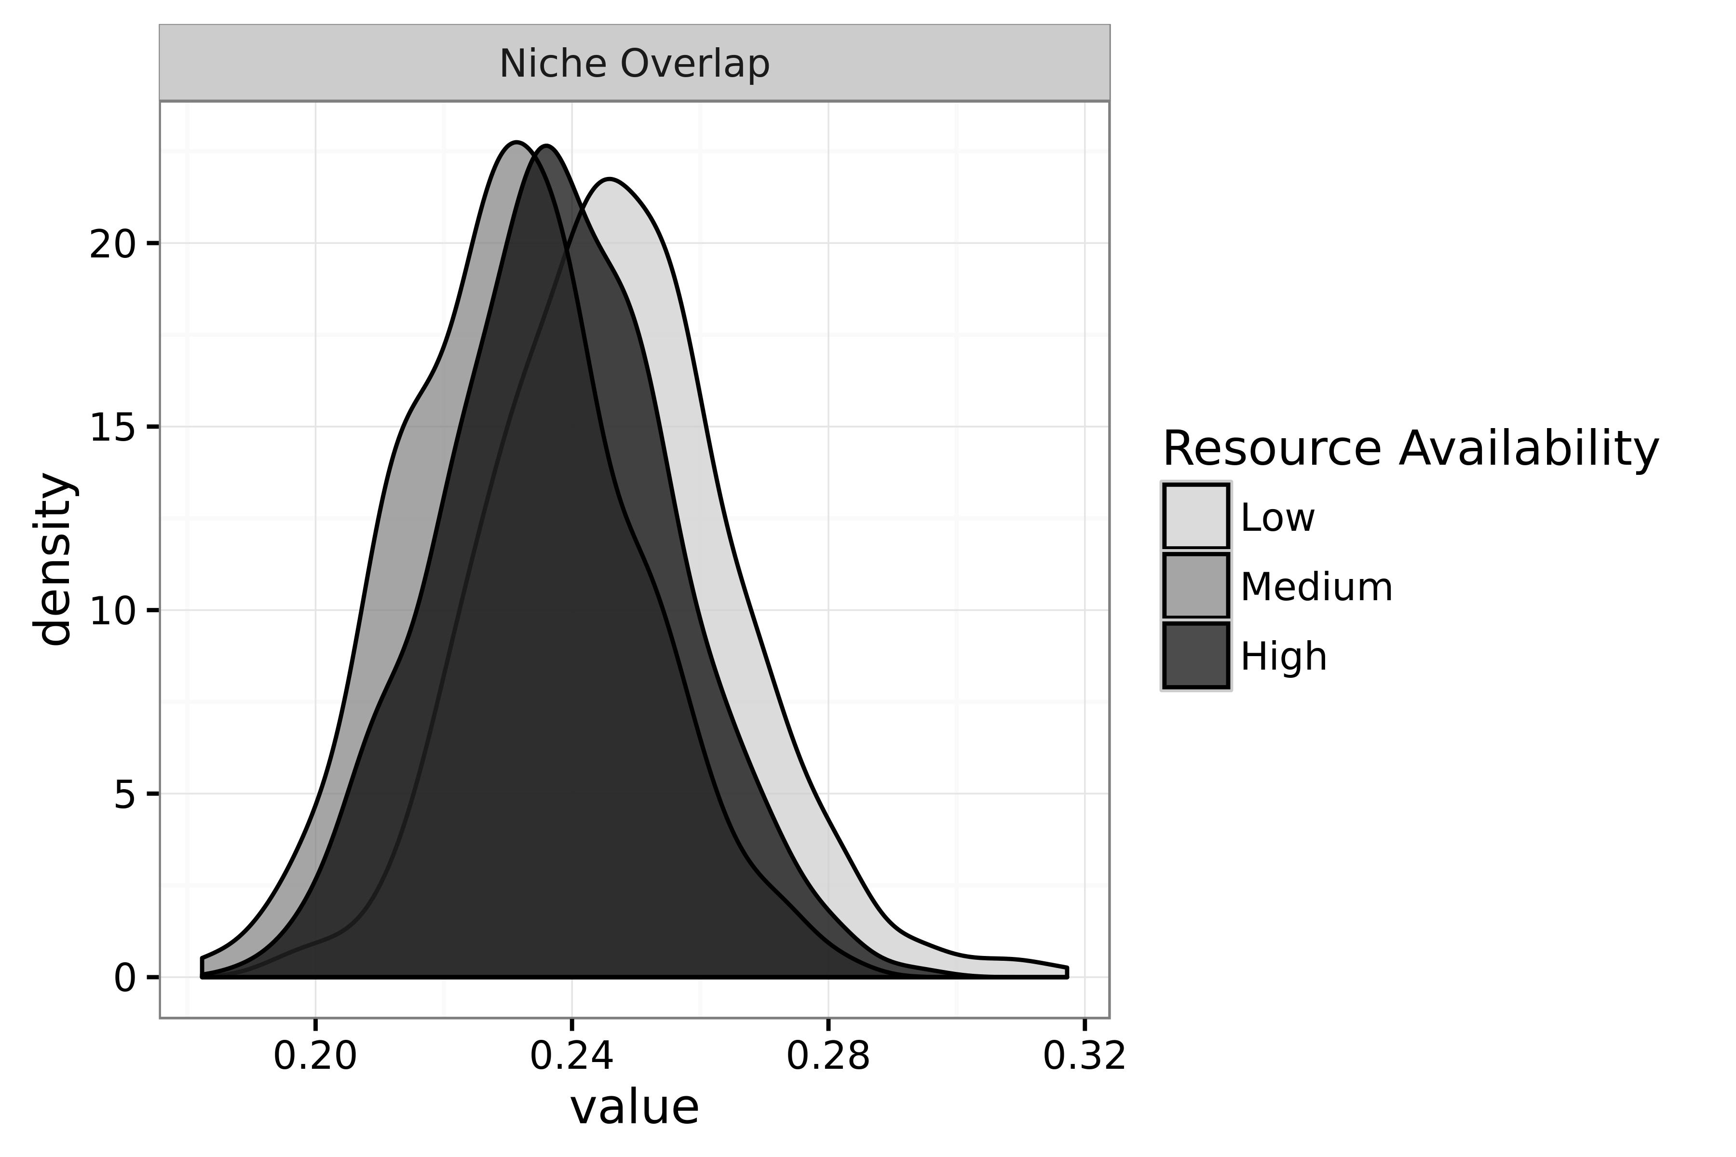

Figure 5. Predicted hummingbird niche overlap during low, medium and high resource availability periods from a cloud-forest in northwest Ecuador. The mean posterior density of the model parameters was used to generate 500 interaction matrices of daily interaction intensity. From each of these matrices we calculated niche overlap in resource use. The variance in niche overlap values stems from the joint uncertainty in observing and predicting species interactions.

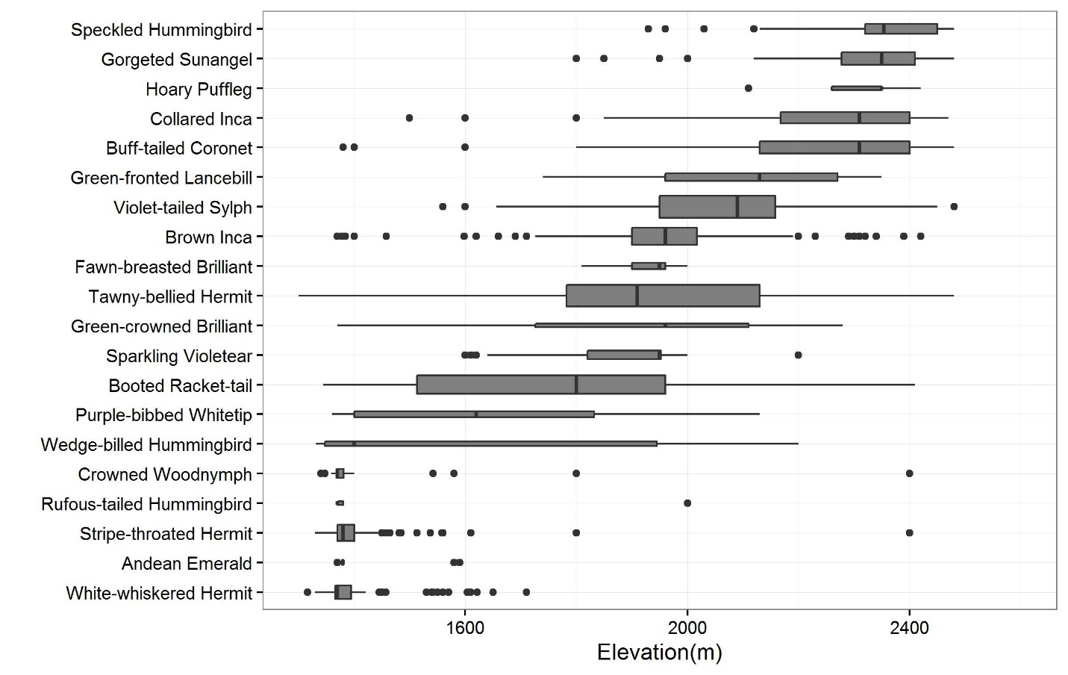Figure S1. Boxplots of the elevation ranges for the hummingbird species as recorded during the floral transects and captured on the time-lapse cameras. The centerline is the median elevation. The box extends from the 25th to 75th quantile. The lines extend 1.5 multiplied by the interquartile range. Data beyond the end of the lines are considered outliers, as specified by Tukey tests, and plotted as points.

Figure S2. The number of observed piercing events during each of the resource availability periods. Flower piercing was defined as a single observation of a hummingbird bypassing the corolla and inserting its bill into the back of the flower.

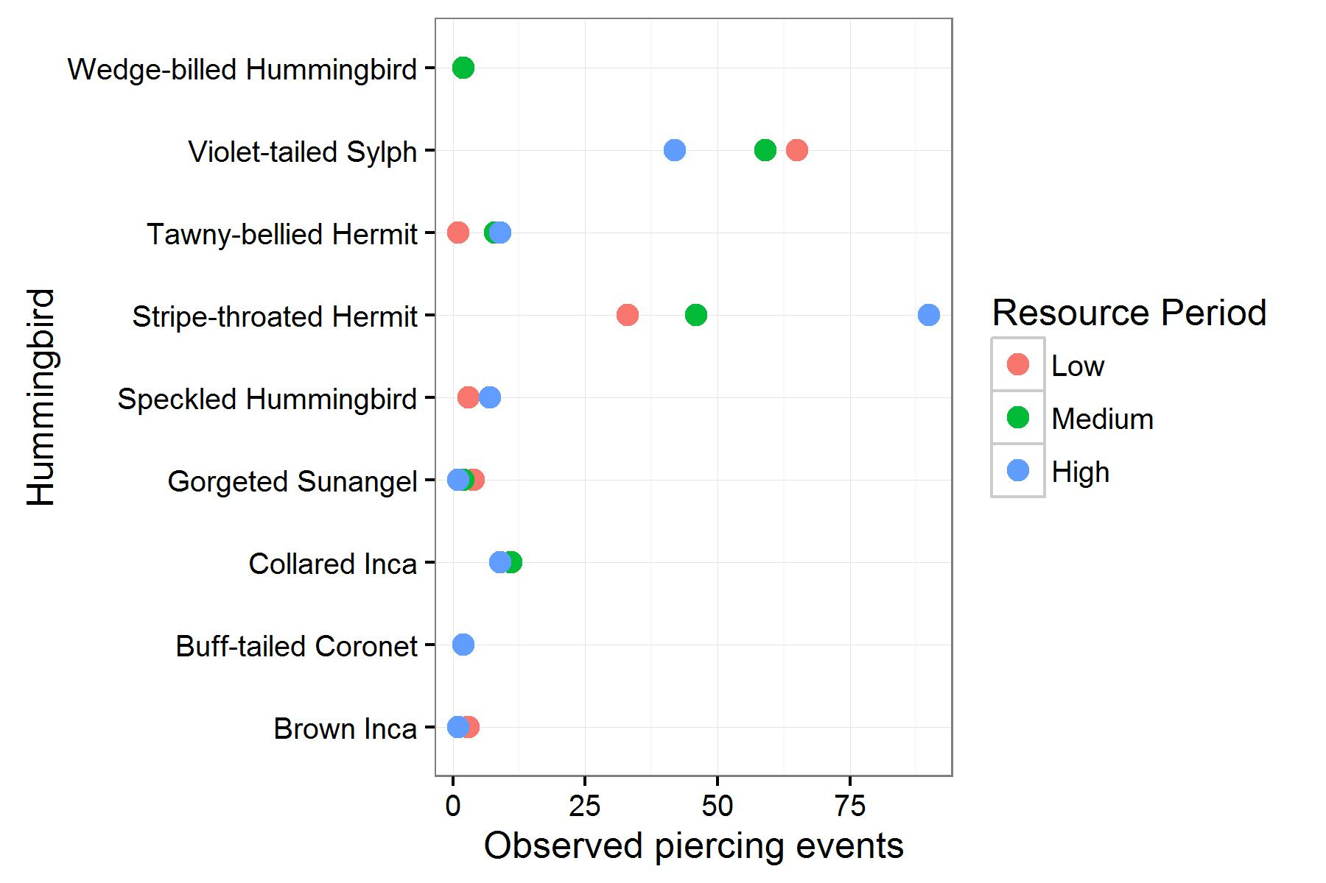

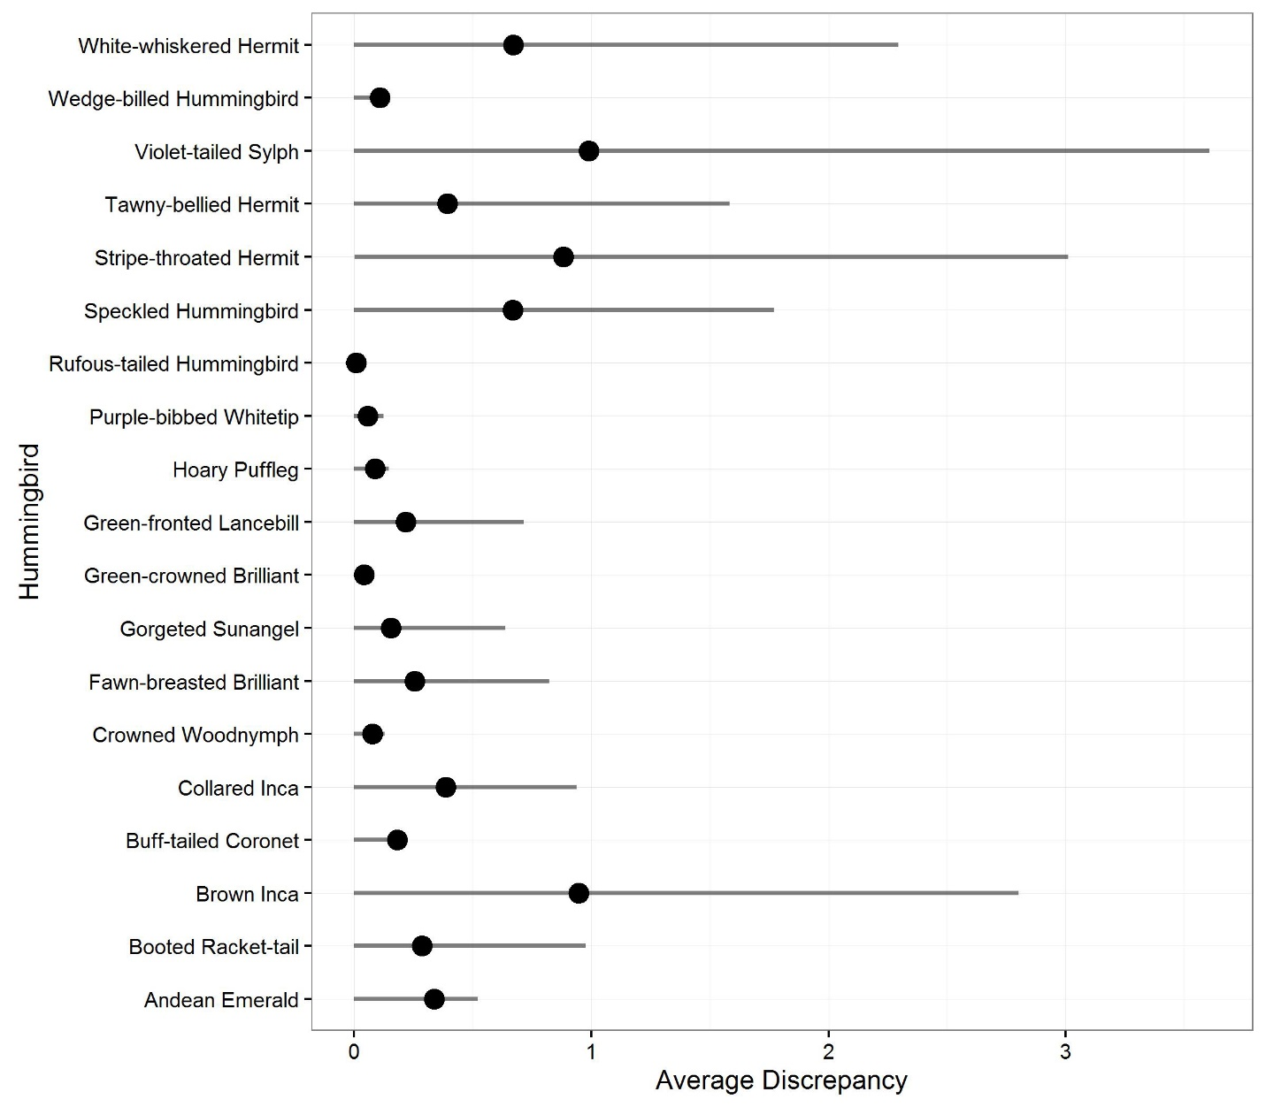

Figure S3. Chi-squared discrepancy between the predicted daily visits from the trait-matching model and the observed visits for each hummingbird species. The mean discrepancy is the black point, with the 95th credible interval shown in the solid line. A lower discrepancy suggests that the trait-matching model was able to more accurately predict the number of visits to a given plant species.

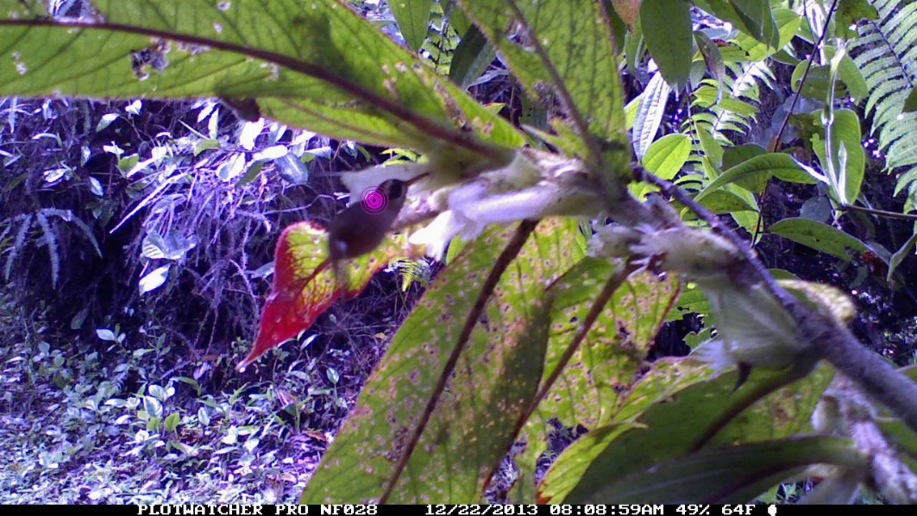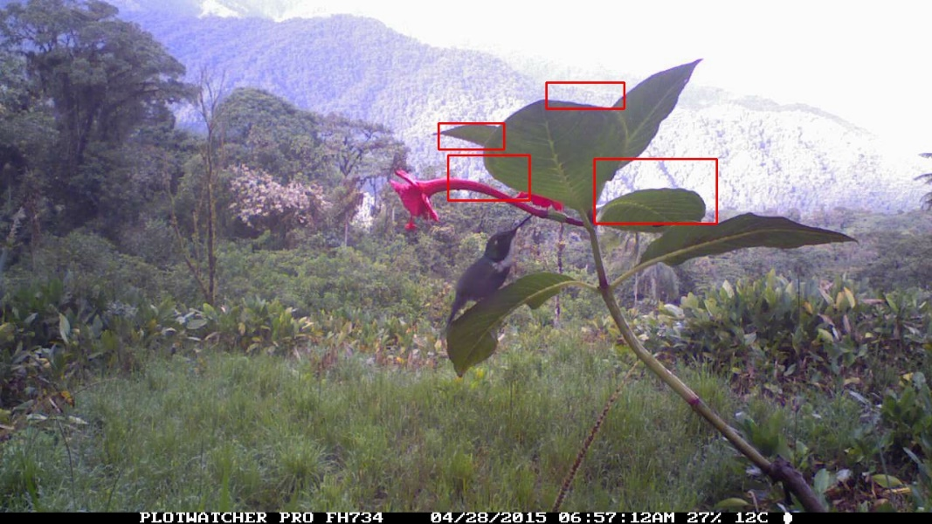

Figure S4. Corolla piercing events by Stripe-throated Hermit on *Columnea cinerea* (top) and Wedge-billed Hummingbird on *Fucshia macrostigma* (bottom). The bullseye and red boxes are artifacts of the early version of our review software used to detect motion events (MotionMeerkat: Weinstein 2015).

|  |  |  |  |  |  |  |
| --- | --- | --- | --- | --- | --- | --- |
| Resource Period | 1300m-1500m | 1500m-1700m | 1700m-1900m | 1900m-2100m | 2100m-2300m | 2300m-2500m |
| High | 19.72 | 21.49 | 14.45 | 17.41 | 21.07 | 21.97 |
| Medium | 19.13 | 21.87 | 23.94 | 26.49 | 25.97 | 23.50 |
| Low | 25.65 | 27.08 | 26.54 | 31.37 | 30.30 | 25.00 |

Table S1. Average corolla lengths (mm) for hummingbird visited flowers for each elevation transect during each resource period in Northwest Ecuador.

Table S2. Flowers not visited by hummingbirds in the raw recorded camera dataset. We made every effort to capture the entire flower resource base. We therefore often put cameras on flowers to validate whether a given plant was hummingbird visited. The following flowers were filmed, but no visitations were found, and they were removed from the analyzed dataset.

|  |  |  |
| --- | --- | --- |
| Species | Cameras | Comments |
| *Begonia longirostris* | 12 | We have incidental observations of Tawny-bellied Hermits and Violet-tailed Sylphs in proximity. Despite repeated camera filming, we do not have clear foraging records. B. longirostris is not known to produce nectar rewards (*pers. comm. P. Moonlight*). |
| *Calathea iscnosiphonoies* | 2 | This fairly common flower is extremely small, and while we have seen female Violet-tailed Sylphs, and a Brown Inca in close proximity, we do not have any visitation records |
| *Centropogon nigricans* | 5 | Green coloration suggests bat pollination. Incidental observation of a Gorgeted Sunangel in close proximity may have been anomalous. |
| *Centropogon preslii* | 1 | This rare flower seems likely to be hummingbird visited. We have only two records of this species on the elevation transects. |
| *Columnea ovatifolia* | 1 | Rare flower found in the mid-canopy. Its pink coloration and tubular shape suggests hummingbird visitation, but we have not recorded visits. |
| *Faramea calyptrata* | 3 | Despite its elongated corolla and dark blue color, hummingbirds do not seem to visit. Other tropical *Faramea* are consisdered hummingbird-visited. |
| *Guzmania squarrosa* | 2 | Fairly rare bromeliad, no visitation records. |
| *Hydrangea peruviana* | 3 | Canopy liana with bright red flowers. Investigation of this flower suggests relative weak nectar production. |
| *Justicia secunda* | 4 | Weedy plant found in secondary habitats. We have an observation of a Stripe-throated Hermit from the transect surveys, but none on the cameras. |
| *Macleania macrantha* | 1 | Taxonomic status of this record is uncertain. Incidental observations of this flower suggest hummingbird visitation, but no visual evidence. |

Table S3. Hummingbird-plant interactions that had greater than a single flower piercing event. Piercing was defined as accessing nectar through inserting the bill through the back of the corolla. Ordered by total observations of piercing events.

|  |  |  |
| --- | --- | --- |
| Hummingbird | Flower | Piercing Events |
| Stripe-throated Hermit | *Glossoloma purpureum* | 56 |
| Stripe-throated Hermit | *Columnea ciliata* | 24 |
| Violet-tailed Sylph | *Glossoloma oblongicalyx* | 14 |
| Violet-tailed Sylph | *Columnea kucyniakii* | 13 |
| Violet-tailed Sylph | *Fuchsia macrostigma* | 13 |
| Violet-tailed Sylph | *Mezobromelia capituligera* | 11 |
| Violet-tailed Sylph | *Centropogon solanifolius* | 9 |
| Violet-tailed Sylph | *Kohleria affinis* | 9 |
| Stripe-throated Hermit | *Columnea picta* | 7 |
| Stripe-throated Hermit | *Columnea mastersonii* | 5 |
| Violet-tailed Sylph | *Columnea picta* | 4 |
| Violet-tailed Sylph | *Palicourea acetosoides* | 4 |
| Violet-tailed Sylph | *Columnea strigosa* | 3 |
| Gorgeted Sunangel | *Drymonia tenuis* | 2 |
| Gorgeted Sunangel | *Macleania bullata* | 2 |
| Speckled Hummingbird | *Glossoloma oblongicalyx* | 2 |
| Stripe-throated Hermit | *Heliconia griggsiana* | 2 |
| Stripe-throated Hermit | *Salvia quitensis* | 2 |
| Violet-tailed Sylph | *Alloplectus tetragonoides* | 2 |
| Violet-tailed Sylph | *Columnea ciliata* | 2 |
| Violet-tailed Sylph | *Pitcairnia sodiroi* | 2 |
| Violet-tailed Sylph | *Psammisia ulbrichiana* | 2 |
| Wedge-billed Hummingbird | *Fuchsia macrostigma* | 2 |

# Acknowledgements

Holger Beck and Nelly Muñoz were instrumental in collecting phenology and interaction data. We would like to thank the tropical botany community for lending expertise in identifications, J. Clark (Gesneriaceae), C. Taylor (Rubiaceae), and P. Pedraza (Ericaceae) were especially helpful with difficult identifications. We thank the families of Maquipucuna and Santa Lucia Reserves for their hospitality and assistance in fieldwork. BGW is supported by a NSF Graduate Research Fellowship. Fieldwork was supported by a National Geographic Committee for Science and Exploration Grant to CHG (#9382-13). The authors declare no conflicts of interest.

**Appendices and Data Availability**

All data, R code, and analysis can be found in reproducible documents at <http://bw4sz.github.io/NetworkPredict/>.